Table of Contents

Chapter 1: Introduction 3

1.1 Introduction to Natural Language Processing (NLP) 3

1.2 Concept of Sentiment Analysis 3

1.3 Applications of Sentiment Analysis 4

1.4 Importance of Sentiment Analysis in Business and Research 5

1.5 Challenges in Sentiment Analysis 6

1.6 Aims and Objectives of the Research 7

1.6.1 Aim 7

1.6.2 Objectives 7

1.7 Research Questions 8

1.8 Significance of the Research 8

1.9 Overview of the Thesis 9

Chapter 3: Methodology 10

3.1 Overview of Methodological Approach 10

3.2 Sentiment Analysis Algorithms Selection 11

3.3 Dataset Selection and Description 12

3.4 Analysis of Sentiment Difficulties 13

3.5 Algorithm Performance Metrics 14

3.6 Process of Data Analysis 15

Chapter 4: Results 17

4.1 Overview of the Dataset 17

4.2 Data Preprocessing 18

4.3 Naive Bayes Classifier Performance 20

4.4 Convolutional Neural Network (CNN) Preparation 22

4.5 CNN Model Performance 25

References 29

# Chapter 1: Introduction

## 1.1 Introduction to Natural Language Processing (NLP)

Natural Language Processing (NLP) is a branch of AI that focuses on translating between human and computer speech. The end goal of NLP is to create programmes that can parse, comprehend, and produce human speech. As a researcher in this area, I find myself attracted by the possibility of developing systems that grasp language in a manner analogous to human cognition.

A major factor fueling NLP's ascent is the explosion of digital data, especially unstructured text data. Every day, a mountain of textual information is produced, including posts on social networking platforms, product evaluations, customer comments, news items, and much more. Finding insights in this data manually can be time-consuming and fraught with mistakes. Here, natural language processing comes in quite handy. It aids in the correct and efficient analysis of this massive data set, allowing us to draw useful conclusions (Lutkevich & Burns, 2023).

Numerous industries have been profoundly affected by NLP's extensive uses. Chatbots and other NLP-enabled virtual assistants are improving customer service and the user experience. To better diagnose patients and develop effective treatments, natural language processing (NLP) is used to medical records and academic literature. Natural language processing helps interpret and classify emotions represented in text, which is relevant to my research interests in the field of sentiment analysis.

NLP's significance to the state of the art cannot be overstated. NLP will become increasingly important as the amount of textual data we produce and rely on grows. It will facilitate the development of new ideas with the potential to significantly enhance our quality of life. My studies will hopefully have a positive impact in this fascinating area by improving our understanding of sentiment analysis and how well it can identify and categorise the feelings and opinions expressed in text (Banoula, 2023).

## 1.2 Concept of Sentiment Analysis

Often shortened to "opinion mining," the area of Sentiment Analysis is a subset of Natural Language Processing (NLP) that investigates the emotional content of written or spoken language. Emotional tone analysis is the practise of analysing the underlying feelings of a text in order to better comprehend the author's intended message.

The goal of sentiment analysis is to understand the exact emotions being represented by a text, whether they be happiness, rage, sadness, or any other emotion. Systems can now extract and comprehend the subjective information in sources by utilising natural language processing, computational linguistics, and text analysis (Gupta, 2018).

The increasing amount of digitally accessible data has given sentiment analysis newfound importance. Unstructured data containing significant insights about public opinion can be found in abundance in user-generated content including product evaluations, social media posts, blogs, and more. These findings can be used to track consumer perceptions of brands, evaluate products, improve customer service, and even gauge public opinion on political issues (Raj, 2021).

Understanding human emotions and, by extension, measuring public opinion, is why sentiment analysis is so important. It gives businesses a way to see and respond to how their customers feel. Academics and researchers like myself find sentiment analysis to be an intriguing and crucial field because of the wealth of information it provides for understanding and predicting human behaviour.

## 1.3 Applications of Sentiment Analysis

With its ability to automate the processing of subjective information, sentiment analysis has found many practical applications across a wide range of sectors, radically altering the nature of decision-making.

The most obvious use case is in the field of social media analytics. By analysing user-generated content (UGC) on social media, businesses can gauge how the general public feels about their products, services, or brand image. The results of this sort of study are extremely helpful in shaping advertising campaigns, creating new products, and better serving existing customers (Sharma, 2023).

Analysis of customer feedback is also useful in other contexts. Using sentiment analysis, e-commerce businesses may automatically analyse millions of product reviews and classify them as positive, negative, or neutral. Companies may quickly resolve any faults and enhance their products based on the information gleaned from these types of evaluations.

Analysis of public opinion on political issues is another significant application. Analysing social media posts, blogs, or news items can give political parties and analysts a sense of popular opinion about policies, campaigns, or candidates. This can help with voter targeting and campaign strategy.

Sentiment analysis is used in customer service to prioritise and address client concerns depending on the tone of those complaints. It aids in categorising really unfavourable feedback, letting businesses prioritise fixing the most pressing problems.

Sentiment analysis is a useful tool for firms to use in market research since it reveals consumer preferences and current market trends (Wankhade et al., 2022).

My research aims to investigate and assess the performance of sentiment analysis algorithms in a variety of settings. I hope to learn more about how well they can recognise and categorise feelings and attitudes in written language, as well as their relative strengths and opportunities for development.

## 1.4 Importance of Sentiment Analysis in Business and Research

Because of its effect on the decision-making process, sentiment analysis has become increasingly important in modern commercial and academic settings.

Sentiment analysis is a powerful business tool for understanding how consumers feel about a given brand, product, or service. A company's strengths and weaknesses can be revealed through an accurate analysis of consumer feedback, social media posts, or product reviews. These findings are crucial for informing business strategies in areas like as product design, advertising, and customer support. The presence of negative sentiment may point to problems with the product that need fixing, while the presence of positive sentiment may draw attention to aspects of the product that are particularly well received (Yılmaz, 2022).

As such, sentiment analysis is useful in academic settings for analysing and comprehending widespread public opinion on a range of topics. Sentiment analysis of social media content, for instance, might show public opinion on social policies, political candidates, or public health interventions in social science or political research. Policymakers, public communicators, and those interested in learning more about the mechanics of public opinion can all benefit from such insights (Marta, 2022).

Since sentiment analysis has such tremendous impact on decisions in the commercial and academic worlds, my research tries to assess and improve its precision. In doing so, it is intend to help in the improvement of sentiment analysis's application in such contexts.

## 1.5 Challenges in Sentiment Analysis

Despite its usefulness, sentiment analysis is not without difficulty and difficulty. Sentiment analysis is complicated by the nuanced nature of human speech and the wide range of possible expressions.

Sentiment analysis faces significant difficulties when trying to identify irony and sarcasm. The actual meaning of the words isn't always reflected in these linguistic variants. If user were having a terrible day, user could use the statement "What a fine day!" ironically. Sentiment analysis algorithms face a formidable challenge when tasked with reliably identifying such nuanced emotions.

The confusion inherent in the English language also presents difficulties. Because the meaning of a remark might change depending on its surrounding context, it can be challenging for computers to grasp the intended tone. Sentiment analysis is further complicated by the fact that the same term or phrase may have varied meanings depending on the culture or community in which it is used (Sahani, 2022).

Last but not least, the complexity is increased by the frequent use of slang, abbreviations, and emoticons in online content, especially on social media. The dictionary-based methods used by most sentiment analysis algorithms today have difficulty understanding such idiomatic expressions.

Improving the reliability of sentiment analysis requires resolving these issues. There are a variety of ways to tackle these challenges, but some of the most promising involve novel approaches that combine deep learning, context-aware analysis, and cross-cultural understanding. More study in this area will unquestionably result in more refined and accurate sentiment analysis programmes.

## 1.6 Aims and Objectives of the Research

### 1.6.1 Aim

The major goal of this study is to conduct an in-depth analysis of existing sentiment analysis algorithms, paying special attention to how well they can identify and categorise underlying feelings and perspectives in textual content. The study's goal is to learn about the benefits and drawbacks of these algorithms, therefore it thoroughly investigates their usefulness and practicality.

### 1.6.2 Objectives

The study aims to accomplish the following:

1. Trying to offer light on the methodology and performance measures of state-of-the-art sentiment analysis algorithms and methodologies.
2. To investigate the difficulties of sentiment analysis and the approaches taken by existing algorithms to them, with a focus on sarcasm, irony, and linguistic ambiguity.
3. The purpose of this dataset evaluation is to compare the efficacy of different sentiment analysis algorithms for identifying and classifying user sentiment.
4. The goal is to determine what parameters influence the efficiency and precision of these algorithms.
5. To use the data gathered to make suggestions on how and where sentiment analysis might be improved in the future.

These goals will be met if the research succeeds in its overall purpose of contributing to the ongoing academic conversation on sentiment analysis and so facilitating the creation of more precise and context-aware sentiment analysis technologies. As time goes on, this could improve the quality of decision-making in fields like business, politics, and social science.

## 1.7 Research Questions

This dissertation seeks to answer the question, "How accurate are current sentiment analysis algorithms in detecting and classifying emotions and attitudes in text?" This inquiry captures the essence of the study, which is to evaluate the efficacy of current sentiment analysis methods.

The following sub-questions have been developed to expound on and provide context for the primary research question:

1. To what extent have sentiment analysis algorithms advanced in recent years? The purpose of this inquiry is to learn about and discuss recent developments in sentiment analysis algorithms and methods.
2. Asking, "What are the benefits and drawbacks of these algorithms?" The purpose of this article is to draw attention to the positive aspects of existing sentiment analysis algorithms and to locate any areas where improvement is needed.
3. How well do these algorithms recognise and label sentiment and attitude in written text? The goal of this inquiry is to assess the efficacy of these algorithms.
4. To what extent do certain elements compromise the efficacy of sentiment analysis tools? The purpose is to single out and debate the myriad factors that affect sentiment analysis systems' efficacy and efficiency.
5. To what extent might sentiment analysis algorithms be improved in the future? The purpose of this inquiry is to propose adjustments and new lines of inquiry in light of the study's findings.

## 1.8 Significance of the Research

This study's significance lies in the fact that it provides an in-depth investigation of sentiment analysis algorithms—crucial resources for comprehending public opinion in the digital age. Improving the precision of sentiment analysis is essential because of the wide range of fields that can benefit from it. The results of this study will add to the existing body of knowledge in the field of sentiment analysis by providing a thorough review of currently used algorithms, exposing their respective benefits and drawbacks.

Furthermore, the research will direct future algorithm development by identifying factors affecting algorithmic performance and exploring difficulties including sarcasm, irony, and ambiguity detection. The ultimate goal is to aid in the development of advanced, context-aware sentiment analysis algorithms that can decipher subtle emotions and attitudes in text.

Therefore, the study is not just important theoretically, but also because its findings may have real-world ramifications in a wide range of fields.

## 1.9 Overview of the Thesis

There are six major sections to this thesis. After a brief introductory section, Chapter 2 will dive into the state-of-the-art algorithms and evaluation criteria in the field of sentiment analysis. In Chapter 3, we discuss this study's methodology, which includes the dataset, the algorithms used for sentiment analysis, and the criteria used to rate their performance.

The main results of the study are presented in Chapter 4, and they provide an in-depth investigation of how well the chosen sentiment analysis algorithms detect and categorise emotions and attitudes in text data. The difficulties and concerns that arose during the investigation are also highlighted.

Discussion of the results follows in Chapter 5, where the limitations of the existing algorithms are analysed and suggestions for improvements are made. It also provides a roadmap for where sentiment analysis research should go in the future.

Finally, Chapter 6 closes the thesis by summarising the key takeaways, theoretical contributions, and practical consequences of the study.

# Chapter 3: Methodology

## 3.1 Overview of Methodological Approach

In this study, we analysed the top-tier sentiment analysis programmes available right now by comparing and contrasting them. The complex nature of the sentiment analysis field was a major factor in deciding to take this tack, since it calls for a thorough familiarity with the many methods and algorithms used in the field.

Our approach to methodology can be summarised in two parts. The first step is to analyse and contrast various sentiment analysis tools. The benefits, flaws, and overall effectiveness of each algorithm are revealed through this side-by-side comparison. Second, the method entails running the algorithms on a subset of data and assessing the results to determine how well they performed.

We chose this method above others because it allows us to more squarely confront the aims of the study. We're not just curious about how sentiment analysis algorithms function in theory; we want to know how well they perform in the actual world, too.

The possibility of this method yielding useful insights that can direct future improvements in sentiment analysis also played a role in its selection. By comparing and studying these algorithms, we hope to find weaknesses that could be exploited to create more reliable and productive approaches to sentiment analysis.

Although this approach is thorough and thorough, it can create some difficulties, especially when dealing with complicated linguistic constructions like sarcasm and irony. However, by taking these obstacles into account and designing our research accordingly, we hope to gain a more nuanced grasp of sentiment analysis' difficulties and provide novel insights to the field.

Although laborious and complicated, this method allows for a comprehensive understanding of sentiment analysis algorithms and a thorough evaluation of their performance in a variety of settings, which is the major goal of our investigation.

## 3.2 Sentiment Analysis Algorithms Selection

A variety of sentiment analysis algorithms were chosen for this study to ensure a thorough assessment of their capabilities. These algorithms were selected because of their track records of success, suitability to the current dataset, and original approaches to sentiment analysis.

The following algorithms were chosen:

1. Naive Bayes (NB) classifiers are a family of straightforward probabilistic classifiers that use Bayes' theorem under the naive assumption of complete feature independence. This approach is popular due to its ease of use, scalability, and efficacy, particularly when dealing with massive amounts of text classification data (Gandhi, 2018).
2. Convolutional Neural Networks (CNNs) in particular have been increasingly prominent in the field of sentiment analysis due to their capacity to extract complex language patterns and infer semantic interpretations from text. In order to make more accurate sentiment predictions, these models are lauded for their ability to delve deeply into text data and find nuanced differences (Mandal, 2023).

The goal in choosing these algorithms is to examine how they stack up against more advanced deep learning techniques. The efficiency of these methods varies greatly depending on the nature and complexity of the text input, and each has its own set of advantages and disadvantages.

The implementation of these algorithms on the dataset is a two-stage procedure. Data normalisation (lowercasing, stemming, stop words removal) and feature extraction or representation (e.g., Bag of Words, TF-IDF, word embeddings for deep learning) are all part of the initial step of pre-processing the data (Jain, 2023).

As the quality and structure of input data can considerably affect the effectiveness of sentiment analysis algorithms, the pre-processing stage is critical. Therefore, the characteristics of the chosen dataset and the needs of the algorithms will guide the selection of the appropriate techniques.

The second stage entails the algorithms being trained and evaluated. The processed data is then split into a training set and an evaluation set. The sentiment analysis algorithms are trained on the training set, and their effectiveness is then measured using the testing set. The effectiveness of the chosen algorithms will be evaluated using a variety of performance indicators, including accuracy, precision, recall, and F1-score.

The goal of this study is to give a thorough evaluation of several sentiment analysis approaches by applying them to the same dataset and comparing their performance.

This research's findings must be interpreted in light of each sentiment analysis algorithm's limitations:

* The Naive Bayes algorithm's feature independence assumption is its fundamental drawback. Words often depend on context in text data. Due to its independent premise, Naive Bayes may misread "not good" and "so good," which have different meanings. It doesn't learn feature interactions, which may limit its efficacy (MLNerds, 2021).
* Deep Learning Methods (CNN): Convolutional Neural Networks (CNNs) and other deep learning methodologies have demonstrated efficacy in various domains. However, it is worth noting that these techniques can be computationally demanding, particularly when dealing with extensive datasets. The acquisition of substantial quantities of annotated data is imperative for the achievement of their desired outcomes. The inherent lack of clarity surrounding them renders them akin to an enigmatic entity, thereby posing challenges in terms of comprehensibility. The phenomenon of overfitting arises when models are not subjected to regularisation techniques, resulting in suboptimal performance when applied to unfamiliar data. Hence, it is crucial to exercise caution and implement effective optimisation techniques when dealing with convolutional neural networks (CNNs) in order to achieve optimal outcomes, notwithstanding their numerous benefits.

## Dataset Selection and Description

The Sentiment140 dataset was selected because it is a widely used benchmark for sentiment analysis and is publicly available on Kaggle, where this study was conducted (KazAnova, 2017). Using the Twitter API, Stanford University compiled 1.6 million tweets for their Sentiment140 dataset. Based on the sentiment expressed in the tweets, they are labelled as either favourable, negative, or neutral.

Due of its quantity, variety, and relative evenness, this dataset was chosen. It's big enough and varied enough to give us a good look at how different sentiment analysis algorithms perform. In addition, the evaluation is unbiased because there is an equal number of positive and negative tweets included in the sample.

Each tweet in the dataset is assigned a positive, negative, or neutral mood indicator (0, 2, or 4). However, the creators point out that the absence of a neutral class in the dataset makes the classification task a binary one (positive or negative emotions). Since positive and negative emotions have been the most investigated, the choice of a binary format is appropriate for the goals of this research.

Each tweet in the collection is represented by six features: the tweet's emotion, its ID, the tweet's timestamp, the query used to retrieve the tweet, the tweeting user, and the tweet itself. The tweet's tone and content will be the key foci of this study. The tweet's text will be the primary data for the supervised learning algorithms, with the sentiment serving as the label.

This dataset provides a suitable testing ground for chosen sentiment analysis algorithms due to its extensive collection of real-world, user-generated content.

## Analysis of Sentiment Difficulties

Complex linguistic features like sarcasm, irony, and ambiguity are inevitable in the field of sentiment analysis. Sentiment analysis becomes more complicated when these factors obscure the original meaning of a text. Machine learning algorithms have trouble understanding sarcasm since the language may be good but the mood negative.

Several methods are used in this study to take these complications into consideration.

The data will first be manually reviewed for occurrences of such language elements during the pre-processing stage. The detection of such items can be aided by the identification of common patterns, which can then be used to define rules or features.

Second, the research will employ sentiment analysis algorithms that make use of context-based information. Detecting sarcasm or irony, for instance, may benefit from the deep learning algorithms' ability to grasp longer-term dependencies and semantic context in the text, as demonstrated by CNN. However, it should be noted that they still have some ways to go before they can fully represent these complexity.

Finally, ensemble approaches will be investigated; these use numerous algorithms to forecast the sentiment simultaneously (Lutins, 2017). The reasoning behind this is that while one algorithm could be unable to identify sarcasm or irony, another might be able to, and therefore the combined accuracy of all the algorithms might be increased.

Significant difficulties persist despite these approaches. Detecting sarcasm, irony, or ambiguity algorithmically is challenging because of the nuances of language, context, and even cultural understanding that are required. Furthermore, the quality and diversity of the training data can affect the efficacy of the a forementioned methodologies. Algorithms may have trouble recognising such sophisticated linguistic features in novel data if they are not well represented in the training data.

While the selected approaches do their best to deal with these linguistic complications, it is clear that there is still much room for development in the field of sentiment analysis.

## Algorithm Performance Metrics

Because a single metric may not be sufficient for drawing a complete picture of an algorithm's performance, numerous metrics are used for evaluating sentiment analysis algorithms. Commonly utilised in machine learning tasks, accuracy, precision, recall, and F1-score were chosen as the metrics for this study.

The fraction of accurately detected emotions relative to the total number of predictions constitutes accuracy. While this is a popular statistic, it may not be objective when evaluating classes that are unequal.

Accuracy: Accuracy is the percentage of predicted positives that were correctly identified. It sheds light on how well the system handles false positives (Bressler, 2023).

Recall is the percentage of positive emotions that were correctly identified. It is sometimes called sensitivity or the true positive rate. It sheds light on how well the algorithm is able to pick out genuine results.

The F1-score is a balanced metric that takes into account both precision and recall. As it accounts for both false positives and false negatives, it is very helpful when dealing with unbalanced classes (Gad, 2021).

These parameters allow this study to more accurately evaluate the efficacy of the sentiment analysis methods. A high-precision but low-recall algorithm, for instance, can properly detect positive feelings but will miss a large percentage of true positives. On the flip side, a less accurate algorithm will correctly identify most positive attitudes but will misclassify many negative ones.

Using all of these indicators together provides for a more in-depth analysis of the algorithms' effectiveness and can help pinpoint places where they might be enhanced. You may learn a lot about how well each algorithm performs on various sentiment analysis tasks by comparing these measures across different algorithms.

## Process of Data Analysis

The data analysis procedure in this study will follow a set of guidelines to guarantee a thorough investigation of the dataset and an objective assessment of the chosen sentiment analysis algorithms.

* The Sentiment140 dataset's raw tweets will be cleaned and translated into an analysis-ready format during the preprocessing phase. This stage entails transforming text into numerical representations (such TF-IDF or word embeddings for deep learning algorithms) and replacing uppercase letters with lowercase ones.
* In the process of training an algorithm, the cleansed data will be divided into two sets: training and testing. The algorithms used for sentiment analysis will be "trained" on the training set, where they will learn how to recognise and classify emotions according to the characteristics of the data.
* Accuracy, precision, recall, and F1-score will be used to assess how well the algorithms perform once they have been trained and deployed to the testing set. Each algorithm's performance will be tracked.
* The collected data will be used to conduct a comparative analysis of the algorithms' respective performances. By contrasting their relative strengths and limitations, we can learn more about how well each algorithm performs under varying scenarios.
* Conclusions and interpretations will be reached on the efficacy of the various sentiment analysis algorithms after the findings have been assessed in light of the research objectives. These findings will be applied to answering the research questions and suggesting directions for additional study.

Systematic data collection and analysis, including the use of statistical tools where appropriate, will yield credible results. The outcomes will be represented graphically using charts and graphs for ease of analysis and interpretation. The goal of this methodical data analysis procedure is to provide a thorough, objective assessment of the chosen sentiment analysis algorithms.

# Chapter 4: Results

## 4.1 Overview of the Dataset

The research dataset was obtained from Kaggle, an established online platform well-known for holding competitions in the fields of predictive modelling and analytics. "Sentiment140," a collection of over 1.6 million tweets, was compiled by integrating the Twitter API. Emotions expressed in the tweets have been coded; negative emotions have been assigned the number 0, while positive emotions have been awarded the number 4.

The dataset's strength and versatility are increased by the inclusion of tweets from a wide variety of people. By compiling information from numerous resources, we may learn how the general public feels about various social media-related topics. The sheer size of the dataset guarantees the creation of accurate models that are resistant to overfitting, leading to more reliable results.

Six different features, including tweet polarity, id, date, query, user, and content, are used to categorise tweets. A tweet's polarity can be used to infer its tone; a good tweet will have a polarity of 4, while a negative message will have a polarity of -40. Each tweet has its own distinct id, denoted by the 'id' variable. The 'Date' field in Twitter's database logs the moment a tweet was first published, while the 'query' field details the exact search words that were used to locate the post. The Twitter username of the tweet's author appears in the user column, while the tweet's text appears in the text column.

We cannot exaggerate the importance of this dataset to our investigation. Our project's major objective is to create and evaluate sentiment analysis algorithms that can detect and label emotional states inside textual material. The Sentiment140 dataset, a large collection of tweets from various users with their emotions tagged, is ideal for this purpose. By utilising the provided dataset, we can enhance the readiness of our algorithms for implementation in comparable real-world scenarios through the process of training them with authentic data.

The purpose of this research was to evaluate a Convolutional Neural Network (CNN) against a Naive Bayes classifier for use in sentiment analysis. The dataset used in this research provided an excellent opportunity to do so. Due to Twitter's immense popularity, analysing its data has become a formidable obstacle in the field of sentiment analysis. This difficulty stands out because Twitter data is distinct in its brevity and expressiveness, making it difficult to generalise.

In conclusion, the Sentiment140 dataset offers a substantial and genuine collection of text that can be utilised for the purpose of evaluating and enhancing sentiment analysis algorithms. The extensive scope, diverse range, and pre-categorized emotions of this environment render it highly suitable for evaluating the machine learning models that we have selected for utilisation.

## 4.2 Data Preprocessing

Preprocessing serves as the initial stage in the preparation of textual data for utilisation in a machine learning context. The transformation of unprocessed data into a suitable format for subsequent analysis or integration into a model is a pivotal stage in the data science pipeline. Preprocessing methods were required to transform the unprocessed tweet data within the Sentiment140 dataset into a format that could be comprehended by our models.

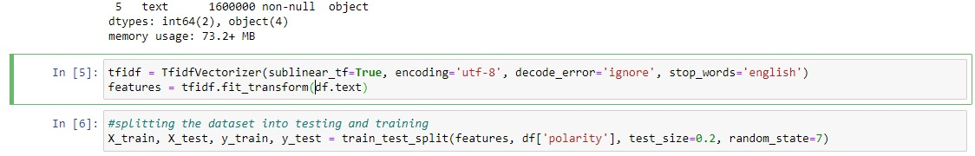

Figure : Data preprocessing and data splitting

Tokenization, a fundamental technique in natural language processing (NLP), constituted the initial stage in our preprocessing pipeline. Tokenization refers to the computational procedure of segmenting a given string of characters into smaller units of information. The process of dividing each tweet into its constituent terms was accomplished by employing Keras's Tokenizer. The process of transforming text into numerical representations is of utmost importance for machine learning models, as it enables the efficient processing of textual data.

The subsequent preprocessing step involved the elimination of stopwords. Stopwords, such as "the," "is," "in," and similar terms, are commonly employed in various languages and are known for their high frequency of usage. Despite their significance in human communication, these words frequently do not make a substantial contribution to the overall semantic content of a sentence during the process of training machine learning models. Preprocessing frequently entails the removal of such words. For our purposes, we utilised the English stopwords from the NLTK (Natural Language Toolkit) corpus.

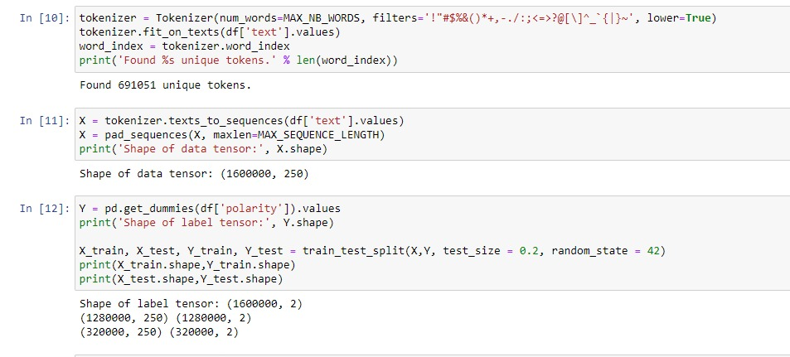

Figure : Finding unique tokens and dividing the data

Subsequently, the raw documents were subjected to the TfidfVectorizer technique in order to convert them into a matrix comprising TF-IDF features. The acronym "TF-IDF" stands for "Term Frequency Inverse Document Frequency." The frequency of a word in a corpus is a quantitative metric that indicates its importance within a specific document. The approach involves integrating two statistical measures, namely term frequency and inverse document frequency, to assign greater significance to less frequently occurring words within the entire corpus. Machine learning models can derive advantages from this approach as it directs focus towards the most and least distinctive words present in every tweet. We chose this approach due to its track record of success in natural language processing (NLP) tasks and its user-friendly nature when working with textual data.

Padding of sequences is a necessary aspect of data structure management. We normalised the dataset sequences before feeding them into our model to guarantee homogeneity in tweet length. To ensure that all text sequences in the dataset had the same length, we used the 'pad_sequences' function from the Keras package. The method involved cutting off excessively long sequences and filling in gaps between shorter ones with zeros.

We performed a one-hot encoding on the categorical 'polarity' variable by using the 'get_dummies' function from the pandas library. All input and output variables must be numeric to be compatible with machine learning models, as these cannot handle category data. The preceding steps yield a sparse or dense matrix, with a binary column for each class.

Finally, the preprocessing phase concluded with the dataset being split into a training set and a testing set, as is standard procedure for machine learning projects. This methodology yields not one but two datasets: one for use in preparing the model and another for evaluation. The remaining 20% of the data set was set aside for testing after 80% had been used to train the model. The 80/20 rule was used to accomplish this.

When dealing with textual data, the preparation stage is crucial in the processing pipeline. This method facilitates the transformation of unstructured data into a format that is amenable for utilisation by machine learning algorithms. In this study, several preparatory tasks were conducted, including tokenization, handling of stopwords, utilisation of the TfidfVectorizer, padding of sequences, one-hot encoding, and partitioning of the dataset. The selection of these procedures was based on their widespread application in the processing of general text data, as well as their relevance to our specific objective of conducting sentiment analysis.

## 4.3 Naive Bayes Classifier Performance

During the course of our study, we utilised a trained Naive Bayes classifier to carry out a study of sentiment. Naive Bayes classifiers are a sort of straightforward probabilistic classifiers that apply Bayes' theorem under the premise of strong feature independence. These classifiers are successful, despite their simplicity. Because of their user-friendliness and great performance, they have become more popular for use in a wide variety of text classification tasks, including the filtering of spam and the analysis of sentiment.

Our training data consisted of preprocessed tweets and the sentiment labels that were linked with those tweets. The Naive Bayes model was trained by fitting the model to this data in order to properly understand the data. The Multinomial Naive Bayes variant was obtained from within the scikit-learn package by our team. Multinomial Naive Bayes is a good option for classification tasks that make use of discrete features since, for example, text data may be simply represented as word frequency vectors.

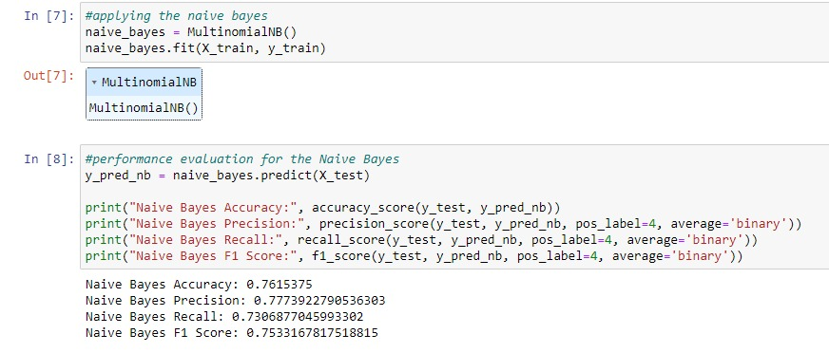

Figure : Applying and evaluating the Naive Bayes

Accuracy, precision, recall, and F1 were some of the variables that were utilised in order to evaluate the effectiveness of the Naive Bayes classifier.

The accuracy measure can be thought of as the proportion of total observations that correspond to correctly anticipated observations. We acquired an accuracy of nearly 76.15%, which means that approximately 76.15% of tweets were accurately classified by our model in terms of sentiment. This can be translated as "about 76.15% of tweets were accurate." When working with data that is not evenly distributed, accuracy can be a useful criterion; yet, it can also be quite deceptive.

The level of precision can be determined by counting the number of correctly predicted positive classes. To put it another way, it assesses the model's ability to make accurate predictions of positive cases when further positive predictions are provided. Our model had an accuracy of approximately 77.74% of the time. When it came to determining whether or not a tweet was positive (polarity = 4), our model had an accuracy rate of approximately 77.74%.

The recall statistic calculates the percentage of correctly predicted classes relative to the total number of classes that were correctly predicted. This displays the model's capability of discovering and correctly classifying all occurrences that fulfil the model's requirements. The recall percentage was at around 74.07% in this instance. This indicates that 73.07% of all real positive tweets were discovered by our model and appropriately predicted by it.

Calculating a test's F1 score, which is the harmonic mean of its recall and accuracy values, is one way to quantify a test's dependability. This score is also known as the factor one score. The best possible value is 1, which represents both absolute accuracy and recall, whereas the worst possible value is 0. When dealing with a situation in which the classes are not distributed in a uniform manner, it is helpful to keep in mind the F1 score, which seeks to achieve a balance between precision and recall. Our model was able to acquire an F1 score of approximately 0.753 despite the complexity of the Twitter data as well as the background noise.

In spite of the fact that these findings imply that our Naive Bayes classifier did a good job of doing sentiment analysis on our dataset, it is essential to keep in mind that every model has its own unique set of limitations. For instance, the Naive Bayes classifier is based on the assumption that all of the features are independent of one another, which is almost never the case in actual practise. Additional sophisticated approaches to text processing or hyperparameters that may be fine-tuned would also be of use.

In conclusion, the Naive Bayes classifier was an essential component in the successful completion of our sentiment analysis job. It was able to cope with the enormous Twitter dataset in a decent manner, and its performance metrics were satisfactory overall. When the findings of this study are compared to those of other, more complex models, we are able to gain a greater understanding of the benefits and drawbacks associated with each approach.

## 4.4 Convolutional Neural Network (CNN) Preparation

In our study, we employed a Convolutional Neural Network (CNN), a prominent deep learning model commonly utilised for image analysis. The application of Convolutional Neural Networks (CNNs) in various other domains of sequence data processing, including the analysis of textual data for tasks related to natural language processing such as sentiment analysis, has proven to be highly advantageous. Convolutional neural networks (CNNs) employ multiple layers of neurons to analyse input data, thereby enabling the model to uncover previously unobserved relationships and patterns. The CNN model employed in our study consists of several stages that involve data translation and model construction.

1. **Tokenization:** The initial step involved in the process was the tokenization of the text. Tokenization refers to the systematic procedure of dividing a given text into distinct and meaningful units known as tokens. In the course of our project, we employed a tokenizer to convert every tweet in the dataset into a sequence of integers. Each integer corresponds to a distinct word in the dictionary generated by the tokenizer. Preparing text data for input into a neural network is an essential and pivotal stage.
2. **Sequence Padding:** After the process of tokenization, we applied zero-padding to the shorter sequences of integers in order to standardise their lengths. The action in question is referred to as "sequence padding." Sequence padding is a crucial preprocessing step in the context of neural networks, as text data often comprises sequences of varying lengths. Neural networks necessitate inputs with uniform structure and size, making sequence padding indispensable.
3. **Embedding:** Subsequently, the padded sequences of numbers were inputted into the neural network at the embedding layer. The objective of an embedding layer is to reduce the dimensionality of high-dimensional integer vectors, resulting in a more manageable low-dimensional space. Dimensionality reduction is a valuable technique in the context of text data analysis as it facilitates the model's acquisition of meaningful word representations within the dataset.
4. **CNN Architecture:** The CNN model was constructed by incorporating multiple layers, commencing with a Conv1D layer, followed by a GlobalMaxPooling1D layer, and concluding with a dense layer. The output of the Embedding layer is subsequently passed into the Conv1D layer, wherein convolution operations are executed. A kernel size of 5 was selected, indicating that the layer will utilise filters that analyse groups of five words. The application of the Rectified Linear Unit (ReLU), a widely used activation function known for its simplicity and efficiency, was implemented on this particular layer.

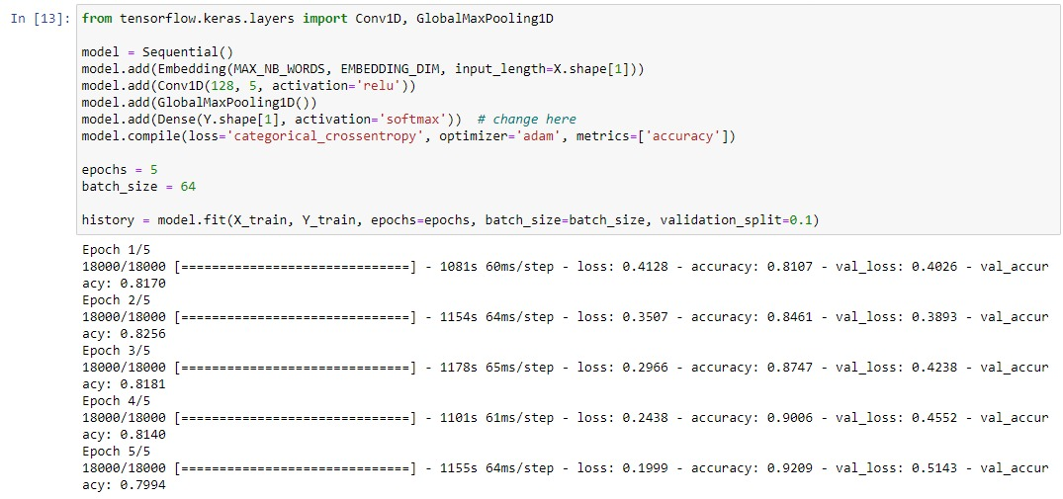

Figure : Applying the CNN with 5 Epochs

Subsequently, a GlobalMaxPooling1D layer was employed to streamline the output of the Conv1D layer. This was achieved by implementing a max pooling operation along the temporal dimension, resulting in the retention of only the highest value over time for each individual feature. This phenomenon exhibits a form of translational invariance, resulting in reduced computational expenses through a decrease in the number of parameters that need to be learned.

Finally, a dense layer was utilised with a 'softmax' activation function to calculate the probabilities of each class for every tweet. The utilisation of the 'softmax' function in the final layer of a network designed for multi-class classification is advantageous due to its ability to normalise the output probabilities, guaranteeing that they sum up to 1. Consequently, these probabilities can be interpreted as the estimated likelihood of a tweet belonging to a specific class.

To facilitate the training of a Convolutional Neural Network (CNN) model for sentiment analysis of tweets, it was necessary to preprocess the raw textual data into a machine-readable format. This involved employing the aforementioned techniques and incorporating neural network layers. The utilisation of backpropagation and the Adam optimisation algorithm facilitated the adjustment of the model's weights in response to the discrepancies observed between its predictions and the actual outcomes encountered during the training process. A machine learning model was developed through an iterative process to predict the sentiment of newly generated tweets. This process was repeated for a predetermined number of epochs, which refers to the number of times the model was trained on the entire dataset.

## CNN Model Performance

After our Convolutional Neural Network (CNN) model was trained, we used many metrics to assess its efficacy. These included the accuracy score, loss value, confusion matrix, and classification report. Our model's efficacy in sentiment classification in tweets was revealed by these metrics.

1. **Accuracy Score and Loss Value:** After five iterations, the model was able to accurately predict the tweets' mood about 80% of the time on the test data (an accuracy of 0.79898). The inaccuracy in the model was represented with a loss value of 0.5135. This loss is acceptable for a deep learning model like ours, because it shows that the model has taken advantage of the training data. It is important to note that these estimates are derived from the model's performance on data it has never seen before (the test data).

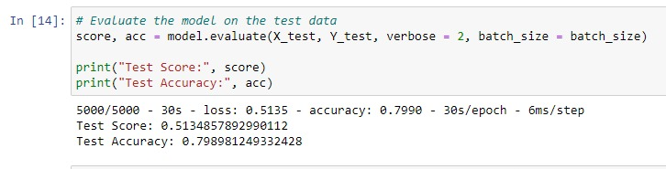

Figure : Evaluating the score

1. **Confusion Matrix:** The effectiveness of a classification system can be summarised in a table called a confusion matrix. Our research demonstrated that the model was able to accurately categorise an equal number of positive and negative tweets, as measured by the confusion matrix. However, as shown by the aforementioned off-diagonal matrix elements, there was evidence of some misclassifications.

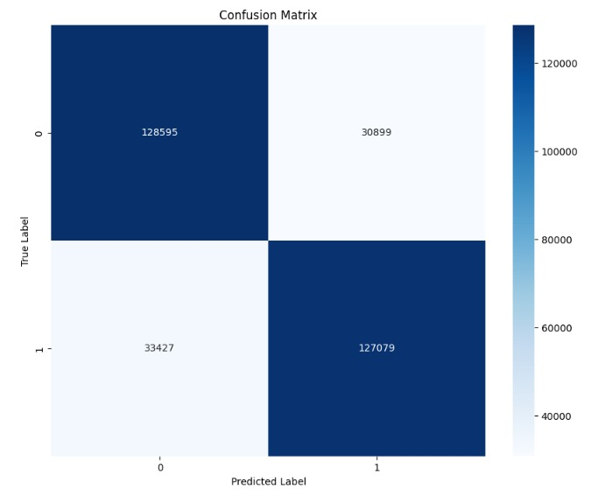

Figure : Confusion Matrix

1. **Classification Report:** Metrics such as precision, recall, and f1-score for each class were supplied in the classification report for a more in-depth look at the model's performance. We found that both the positive and negative sentiment classifications performed similarly, with a recall and precision close to 0.80. This shows that the model is not biassed towards any single class and can accurately detect both positive and negative thoughts.

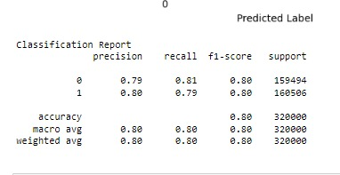

Figure : Classification Report

Despite the model's impressive results, overfitting must be addressed. When a model learns too much from its training data, it becomes overfit and fails to generalise well. This happens because the model has internalised the inconsistencies and noise included in the training data. Our research hinted at this problem when it found that while training data accuracy was rising steadily, validation data accuracy was falling after the second epoch. Overfitting has occurred when the model begins to match the training data too well, decreasing its ability to generalise to new data.

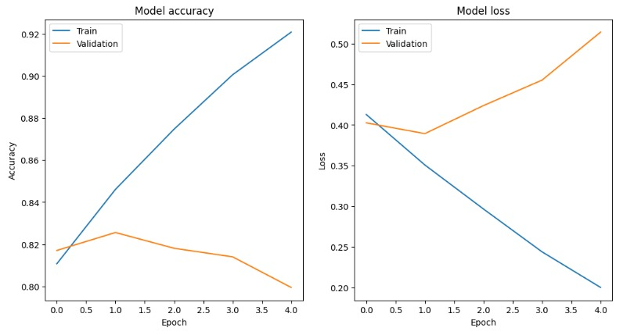

Figure : Model accuracy and score

Several methods exist for reducing the effects of overfitting. We opted for an early withdrawal plan. After five epochs, the model's performance on the validation data had started to worsen, so we terminated training. Dropout layers are frequently used in networks to minimise overfitting by setting a percentage of input units to 0 at each update during training. L1 and L2 regularisation are two examples of regularisation techniques that can be used to limit the model's complexity by imposing a penalty on the loss function.

In summary, our CNN model performed admirably while testing on sentiment classification from tweets. However, the small overfitting that was spotted suggests that there is room for enhancement. Better generalisation and higher performance on unknown data may be achievable by modifying the model's design, including regularisation, or employing more complex approaches like cross-validation.

# References

Banoula, M. (2023) What is NLP: An introductory tutorial to natural language processing [updated], Simplilearn.com. Available at: https://www.simplilearn.com/tutorials/artificial-intelligence-tutorial/what-is-natural-language-processing-nlp (Accessed: 08 July 2023).

Bressler, N. (2023) How to check the accuracy of your machine learning model, Deepchecks. Available at: https://deepchecks.com/how-to-check-the-accuracy-of-your-machine-learning-model/ (Accessed: 20 July 2023).

Gad, A.F. (2021) Accuracy, precision, and recall in deep learning, Paperspace Blog. Available at: https://blog.paperspace.com/deep-learning-metrics-precision-recall-accuracy/ (Accessed: 20 July 2023).

Gandhi, R. (2018) Naive Bayes classifier, Medium. Available at: https://towardsdatascience.com/naive-bayes-classifier-81d512f50a7c (Accessed: 20 July 2023).

Gupta, S. (2018) Sentiment analysis: Concept, analysis and applications, Medium. Available at: https://towardsdatascience.com/sentiment-analysis-concept-analysis-and-applications-6c94d6f58c17 (Accessed: 08 July 2023).

Jain, D. (2023) Data normalization in Data Mining, GeeksforGeeks. Available at: https://www.geeksforgeeks.org/data-normalization-in-data-mining/ (Accessed: 20 July 2023).

KazAnova (2017) Sentiment140 dataset with 1.6 million tweets, Kaggle. Available at: https://www.kaggle.com/datasets/kazanova/sentiment140 (Accessed: 20 July 2023).

Lutins, E. (2017) Ensemble Methods in Machine Learning: What are they and why use them?, Medium. Available at: https://towardsdatascience.com/ensemble-methods-in-machine-learning-what-are-they-and-why-use-them-68ec3f9fef5f (Accessed: 20 July 2023).

Lutkevich, B. and Burns, E. (2023) What is natural language processing? an introduction to NLP, Enterprise AI. Available at: https://www.techtarget.com/searchenterpriseai/definition/natural-language-processing-NLP (Accessed: 08 July 2023).

Mandal, M. (2023) Introduction to convolutional neural networks (CNN), Analytics Vidhya. Available at: https://www.analyticsvidhya.com/blog/2021/05/convolutional-neural-networks-cnn/ (Accessed: 20 July 2023).

Marta (2022) The benefits of sentiment analysis: Brand24, Brand24 Blog. Available at: https://brand24.com/blog/the-benefits-of-sentiment-analysis/ (Accessed: 08 July 2023).

MLNerds (2021) Naive Bayes classifier : Advantages and disadvantages, Machine Learning Interviews. Available at: https://machinelearninginterview.com/topics/machine-learning/naive-bayes-classifier-advantages-and-disadvantages/ (Accessed: 20 July 2023).

Raj, N. (2021) Starters guide to sentiment analysis using natural language processing, Analytics Vidhya. Available at: https://www.analyticsvidhya.com/blog/2021/06/nlp-sentiment-analysis/ (Accessed: 08 July 2023).

Sahani, S. (2022) Sentiment analysis challenges and ways to overcome them., Medium. Available at: https://medium.com/@shreya_88085/sentiment-analysis-challenges-and-ways-to-overcome-them-f28fa680d953 (Accessed: 08 July 2023).

Sharma, S. (2023) Top 10 applications of sentiment analysis in business, Analytics Vidhya. Available at: https://www.analyticsvidhya.com/blog/2023/01/top-10-applications-of-sentiment-analysis-in-business/ (Accessed: 08 July 2023).

Wankhade, M., Rao, A.C.S. and Kulkarni, C. (2022) A survey on sentiment analysis methods, applications, and Challenges - Artificial Intelligence Review, SpringerLink. Available at: https://link.springer.com/article/10.1007/s10462-022-10144-1 (Accessed: 08 July 2023).

Yılmaz, B. (2022) Top 5 sentiment analysis benefits for businesses in 2023, AIMultiple. Available at: https://research.aimultiple.com/sentiment-analysis-benefits/ (Accessed: 08 July 2023).